Human Physiology: An Integrated Approach, 7e, Global Edition (Silverthorn)
Chapter 1 Introduction to Physiology

1) Physiology is the study of
A) the structure of the body.
B) the tissues and organs of the body at the microscopic level.
C) growth and reproduction.
D) the normal function of living organisms.
E) the facial features as an indication of personality.
Answer: D
Section: Physiology Is an Integrative Science
Learning Outcome: 1.1
Bloom's Taxonomy: Knowledge

2) The literal meaning of the term physiology is knowledge of
A) organs.
B) nature.
C) science.
D) chemistry.
E) math.
Answer: B
Section: Physiology Is an Integrative Science
Learning Outcome: 1.1
Bloom's Taxonomy: Knowledge

3) Because anatomy and physiology have different definitions, they are usually considered separately in studies of the body.
A) True
B) False
Answer: B
Section: Physiology Is an Integrative Science
Learning Outcome: 1.1
Bloom's Taxonomy: Knowledge

4) The following is a list of several levels of organization that make up the human body.
1. tissue
2. cell
3. organ
4. molecule
5. organism
6. organ system

The correct order from the smallest to the largest is
A) 2, 4, 1, 3, 6, 5.
B) 4, 2, 1, 6, 3, 5.
C) 4, 2, 1, 3, 6, 5.
D) 4, 2, 3, 1, 6, 5.
E) 6, 4, 5, 2, 3, 1.
Answer: C
Section: Physiology Is an Integrative Science
Learning Outcome: 1.2
Bloom's Taxonomy: Knowledge
5) "Glucose is transported from blood into cells because cells require glucose to meet their energy needs." This type of explanation is
A) mechanistic.
B) theological.
C) teleological.
D) metalogical.
E) scatological.
Answer: C
Section: Function and Mechanism
Learning Outcome: 1.4
Bloom's Taxonomy: Comprehension

6) "Glucose is transported from blood into cells by transporters in response to insulin." This type of explanation is
A) mechanistic.
B) theological.
C) teleological.
D) metalogical.
E) scatological.
Answer: A
Section: Function and Mechanism
Learning Outcome: 1.4
Bloom's Taxonomy: Comprehension

7) Which of the following is a buffer zone between the outside world and most of the cells of the body?
A) cell membrane
B) red blood cells
C) intracellular fluid
D) extracellular fluid
E) All of the answers are correct.
Answer: D
Section: Homeostasis
Learning Outcome: 1.7
Bloom's Taxonomy: Comprehension

8) Which of the following is one of Cannon's "internal secretions"?
A) hormones
B) nutrients
C) water
D) inorganic ions
E) None of the answers are correct.
Answer: A
Section: Homeostasis
Learning Outcome: 1.6
Bloom's Taxonomy: Knowledge
9) The study of body function in a disease state is
A) necrology.
B) physiology.
C) microbiology.
D) pathophysiology.
E) histology.
Answer: D
Section: Homeostasis
Learning Outcome: 1.6
Bloom's Taxonomy: Knowledge

10) Homeostasis is the ability of the body to
A) prevent the external environment from changing.
B) prevent the internal environment from changing.
C) quickly restore changed conditions to normal.
D) ignore external stimuli to remain in a state of rest.
E) prevent excessive blood loss.
Answer: C
Section: Homeostasis
Learning Outcome: 1.6
Bloom's Taxonomy: Comprehension

11) Oxytocin is a hormone that is released in response to cervical dilation. It in turn causes more uterine contractions that will further dilate the cervix. Which type of feedback loop does oxytocin trigger?
A) negative feedback
B) positive feedback
C) local control
D) nociceptive feedback
Answer: B
Section: Control Systems and Homeostasis
Learning Outcome: 1.16
Bloom's Taxonomy: Comprehension

12) How genetics influences the body's response to drugs is called
A) pharmacokinetics.
B) pharmacogenetics.
C) pharmacogenomics.
D) pharmacodynamics.
E) pharmageddon.
Answer: C
Section: Physiology Is an Integrative Science
Learning Outcome: 1.1
Bloom's Taxonomy: Knowledge
13) A physician basing clinical decisions on primary research published in biomedical literature is doing ________ medicine.
A) evidence-based
B) traditional
C) alternative
D) whimsical
E) holistic
Answer: A
Section: The Science of Physiology
Learning Outcome: 1.18
Bloom's Taxonomy: Comprehension

14) A study in which a participant acts as an experimental subject in part of the experiment and a control in another part of the experiment is called a ________ study.
A) double-blind
B) crossover
C) meta-analysis
D) retrospective
Answer: B
Section: The Science of Physiology
Learning Outcome: 1.19
Bloom's Taxonomy: Knowledge

15) The Internet database for molecular, cellular, and physiological information is called the ________ Project.
A) Human Genome
B) Physiognomy
C) Physiosome
D) Physiome
E) Manhattan
Answer: D
Section: Physiology Is an Integrative Science
Learning Outcome: 1.1
Bloom's Taxonomy: Knowledge

16) A placebo is
A) any drug being tested in a clinical trial.
B) any drug in a class of drugs commonly used as pain relievers.
C) a drug or treatment that is expected to have no pharmacological effect.
D) a nutritive and respiratory organ in fetal development.
E) a hole in a cavity wall through which an organ protrudes.
Answer: C
Section: The Science of Physiology
Learning Outcome: 1.20
Bloom's Taxonomy: Comprehension
17) A technique used to resolve contradictory results in scientific studies is
A) meta-analysis.
B) retrospective analysis.
C) prospective analysis.
D) cross-sectional analysis.
E) longitudinal analysis.
Answer: A
Section: The Science of Physiology
Learning Outcome: 1.19
Bloom's Taxonomy: Knowledge

18) A scientifically logical guess is a
A) model.
B) theory.
C) hypothesis.
D) law.
E) variable.
Answer: C
Section: The Science of Physiology
Learning Outcome: 1.18
Bloom's Taxonomy: Knowledge

19) If a scientific model is supported or verified repeatedly by multiple investigators, it may become a
A) model.
B) theory.
C) hypothesis.
D) law.
E) variable.
Answer: B
Section: The Science of Physiology
Learning Outcome: 1.18
Bloom's Taxonomy: Knowledge

20) Place these terms in the typical sequence in which they appear in the process of scientific inquiry: experimental data, theory, model, observation, hypothesis, replication.
A) experimental data, theory, model, observation, hypothesis, replication
B) replication, hypothesis, experimental data, theory, model, observation
C) theory, observation, experimental data, hypothesis, replication, model
D) observation, replication, model, experimental data, hypothesis, theory
E) observation, hypothesis, experimental data, replication, model, theory
Answer: E
Section: The Science of Physiology
Learning Outcome: 1.18
Bloom's Taxonomy: Comprehension
21) You are interested in learning more about Parkinson's disease, a neurological disorder that primarily affects motor function. Which is the best source to begin your investigation?
A) Ask.com
B) MedlinePlusPubMed
C) public library
D) physiology textbook
E) a physician
Answer: B
Section: The Science of Physiology
Learning Outcome: 1.18
Bloom's Taxonomy: Knowledge

22) Which of the following systems does NOT exchange material with the internal and external environments?
A) respiratory system
B) circulatory system
C) digestive system
D) urinary system
E) All of the above.
Answer: B
Section: Physiology Is an Integrative Science
Learning Outcome: 1.3
Bloom's Taxonomy: Knowledge

23) The human environment is terrestrial, dry, and highly variable. However, our bodies expend enormous amounts of energy maintaining a constant internal environment. Studying why our bodies do this is what kind of scientific endeavor?
A) mechanistic
B) translational
C) teleological
D) anatomical
E) meterological
Answer: C
Section: Physiology Is an Integrative Science
Learning Outcome: 1.4
Bloom's Taxonomy: Comprehension

24) Individuals with Type I diabetes do not make enough insulin. Which of the following would be a mechanistic explanation of how insulin is used by the body?
A) Cells need insulin because glucose will not cross the cell membrane.
B) Insulin is a hormone involved in glucose transport.
C) Insulin binds to its receptor which triggers the movement of glucose transporters to the cell membrane.
D) Since all cells need glucose, insulin is required.
E) Without insulin most cells in the body would be unable to produce enough ATP.
Answer: C
Section: Physiology Is an Integrative Science
Learning Outcome: 1.4
Bloom's Taxonomy: Comprehension
25) Excretion is a function of the body. Which of the following would be considered excretion?
A) Movement of sodium from the intestines to the bloodstream.
B) Movement of glucose from the kidney to the blood stream.
C) Movement of potassium from kidney cells into one's urine.
D) Movement of salt from sweat glands to the surface of the skin.
E) Movement of oxygen from the lungs to the blood stream.
Answer: D
Section: Homeostasis
Learning Outcome: 1.10
Bloom's Taxonomy: Application

26) What is a nocebo effect?
Answer: It is the phenomenon whereby a patient who has been informed of the side effects of a drug he is taking is more likely to experience some of the side effects than an otherwise similar patient receiving the same drug who has not been so informed.
Section: The Science of Physiology
Learning Outcome: 1.20
Bloom's Taxonomy: Knowledge

27) List the key concepts or themes in physiology.
Answer: See Table 1.1 in the chapter.
Section: Themes in Physiology
Learning Outcome: 1.5
Bloom's Taxonomy: Knowledge

28) Adaptive significance is an important concept in physiology because it describes the
A) importance of a highly variable external environment.
B) physiological functions that promote an organism's survival.
C) ability of an organism to monitor and restore its internal state to normal conditions when necessary.
D) similarities between ancient and modern marine organisms.
E) parameters necessary to maintain a constant internal environment.
Answer: B
Section: Function and Mechanism
Learning Outcome: 1.4
Bloom's Taxonomy: Comprehension

29) You conduct an experiment on twenty 18-year-old male subjects to see how various intensities of exercise influence heart rate. Which of the following is/are considered an independent variable?
A) age of subjects
B) sex of subjects
C) intensity of exercise
D) heart rate
E) More than one of the answers is correct.
Answer: C
Section: The Science of Physiology
Learning Outcome: 1.18
Bloom's Taxonomy: Application
30) You conduct an experiment on twenty 18-year-old male subjects to see how various intensities of exercise influence heart rate. Which of the following is/are considered a dependent variable?
A) age of subjects
B) sex of subjects
C) intensity of exercise
D) heart rate
E) More than one of the answers is correct.
Answer: D
Section: The Science of Physiology
Learning Outcome: 1.18
Bloom's Taxonomy: Application

31) Why are physiology and anatomy frequently studied together?
Answer: This is discussed in the "Physiology Is an Integrative Science" section of the chapter.
Section: Physiology Is an Integrative Science
Learning Outcome: 1.1
Bloom's Taxonomy: Application

32) You want to display data on the finish times of the 10 fastest race horses in a single race at the Kentucky Derby.
Which type of graph would be best to display this information?
A) bar graph
B) line graph
C) scatter plot
Answer: A
Section: The Science of Physiology
Learning Outcome: 1.18
Bloom's Taxonomy: Application

33) You want to display data on the finish times of the 10 fastest race horses in a single race at the Kentucky Derby.
What would the labels be for the graph axes?
Answer: The x-axis is horse name or number; the y-axis is finish time in minutes.
Section: The Science of Physiology
Learning Outcome: 1.18
Bloom's Taxonomy: Application

34) A horse runs 10 races, each a mile long, during a 6-month period, and you are interested in determining if the horse's race time changes with experience. You set up a graph to display the race finish times of this horse.
Which type of graph would be best to display the race finish times of this horse?
A) bar graph
B) line graph
C) scatter plot
Answer: B
Section: The Science of Physiology
Learning Outcome: 1.18
Bloom's Taxonomy: Application
35) A horse runs 10 races, each a mile long, during a 6-month period, and you are interested in determining if the horse's race time changes with experience. You set up a graph to display the race finish times of this horse.
What would the labels be for the graph axes?
Answer: The x-axis is race number or date; the y-axis is finish time in minutes.
Section: The Science of Physiology
Learning Outcome: 1.18
Bloom's Taxonomy: Application

36) There are 10 cloned horses, born on the same day, with identical chromosomes. They are each subjected to the same physical training regimen, but given daily injections of different concentrations of a particular vitamin. They all run the same race. You set up a graph to explore a relationship between race finish time and vitamin dose.
Which type of graph is best to explore a relationship between race finish time and vitamin dose?
A) bar graph
B) line graph
C) scatter plot
Answer: C
Section: The Science of Physiology
Learning Outcome: 1.18
Bloom's Taxonomy: Application

37) There are 10 cloned horses, born on the same day, with identical chromosomes. They are each subjected to the same physical training regimen, but given daily injections of different concentrations of a particular vitamin. They all run the same race. You set up a graph to explore a relationship between race finish time and vitamin dose.
What are the labels for the graph axes?
Answer: The x-axis is vitamin dose; the y-axis is finish time in minutes.
Section: The Science of Physiology
Learning Outcome: 1.18
Bloom's Taxonomy: Application

38) What is the difference between a peer-reviewed article and a review article?
Answer: A peer-reviewed article describes original research by one author (or group of authors working together) that has gone through a screening process in which a panel of qualified scientists evaluate the work. A review article is a summary (usually a collection of published research that was previously peer-reviewed, usually from more than one independent lab) that discusses a particular topic in the field.
Section: The Science of Physiology
Learning Outcome: 1.18
Bloom's Taxonomy: Analysis

39) What is the major problem with the deconstructionist view of biology?
Answer: Return to the topic of function and process. The deconstructionist view of biology predicted that once we uncovered the sequence of the human genome, the inner workings of the human body would be revealed. In reality, it is possible to know HOW a gene codes for a particular protein without knowing WHY that protein exists. Our knowledge of the human genome is only a piece of the puzzle.
Section: Physiology Is an Integrative Science
Learning Outcome: 1.1
Bloom's Taxonomy: Comprehension
40) Sarah has just flown around the world in the last 48 hours. She is having trouble sleeping, a condition known as insomnia. How do you think Sarah's long flights and her insomnia are related to biological rhythms?
Answer: Our sleep-wake cycle is a biological rhythm that lets our body know when it is time to rest. Most likely Sarah has ignored the signals like sleepiness, changes in body temperature, and mood that her body is sending. By ignoring these rhythms she has disrupted the cycle and the body is struggling to maintain homeostasis.
Section: Control Systems and Homeostasis
Learning Outcome: 1.17
Bloom's Taxonomy: Application

41) Why is it necessary to label the axes of a graph?
Answer: A graph with no axis labels is meaningless—without knowing what trend is being illustrated, there is no communication of scientific information.
Section: The Science of Physiology
Learning Outcome: 1.18
Bloom's Taxonomy: Comprehension

42) Why is it necessary to space grid marks on a graph proportionally to the quantity measured (example: each square represents one centimeter)?
Answer: If this is not done, a trend would be obscured or even misrepresented.
Section: The Science of Physiology
Learning Outcome: 1.18
Bloom's Taxonomy: Comprehension

43) Explain why the prefix homeo- is used in the term homeostasis. Why do some physiologists prefer the term homeodynamics over homeostasis?
Answer: The prefix homeo-, meaning like or similar, is used to indicate that the body's internal environment is maintained within a range of acceptable values rather than a fixed state. Some physiologists argue that the term homeodynamics better reflects the small but constant changes that continuously take place in the internal environment, as opposed to homeostasis, which erroneously implies lack of change.
Section: Homeostasis
Learning Outcome: 1.6
Bloom's Taxonomy: Comprehension
44) Explain why animals are used in research. Are there any limitations to the application of animal data to human physiology? Could these limitations be addressed using cell or tissue culture, or computer simulations?
Answer: (Note to instructor: This may be a good question to ask early in the semester, then again toward the end, after the organ systems have been covered.) There is a brief discussion of using humans or animals in research in the chapter. This question is intended to stimulate students to think about how science is done, how data are generated, and how the process is challenged by social issues. Generally, there are limitations to the usefulness of computer simulations and cell/tissue culture systems for the same reason that nonhuman animal data are not 100% applicable to human physiology. How human organ systems perform may be different in very subtle ways from corresponding systems in other species. Cells in culture are in an artificial environment, and while much has been learned from such systems, it has also been noted that the behavior of cells in culture is not identical to cells in a living body. Furthermore, cells cultured from established lines can change over time, becoming less like the original cells from which they were derived, and presumably less like normal cells. Computer simulations are valuable, but are only as good as the data entered, and given that we don't know everything there is to know about physiology, we can't write a perfect computer program. All three approaches are useful, but for different reasons, and therefore one research system does not completely substitute for another, nor is it appropriate to abandon one entirely.
Section: The Science of Physiology
Learning Outcome: 1.18
Bloom's Taxonomy: Analysis

45) You conduct an experiment on twenty 18-year-old male subjects to see how various levels of exercise influence heart rate. Explain why only 18-year-old males were used as subjects.
Answer: An important part of scientific inquiry is to remove sources of variation from among subjects. By choosing subjects of one gender in a particular age group, it is easier to determine that the dependent variable (heart rate, in this case) depends only on the independent variable, level of exercise. This also allows a study to have fewer participants, assuming that subjects were randomly assigned to a level of exercise. If subjects were of random ages and genders, data would have to be collected from many more individuals.
Section: The Science of Physiology
Learning Outcome: 1.18
Bloom's Taxonomy: Application

46) Use the following terms to develop a concept map:
brain, sensory neuron, an eye, foot, soccer ball, motor neuron
Answer: Eye sees soccer ball.
Sensory neuron sends visual information.
Brain receives information and formulates a plan.
Motor neuron carries action information.
Foot muscle contracts and the ball is kicked.
Section: Control Systems and Homeostasis
Learning Outcome: 1.12
Bloom's Taxonomy: Application
47) Provide an example of a control system. Be sure to include the three main components: an input signal, a controller, and an output signal.
Answer: Variable. One example is blood glucose concentration. The input signal is a blood glucose concentration outside of the normal range, the controller is the pancreas, and the output signal is release of either insulin or glucagon.
Section: Control Systems and Homeostasis
Learning Outcome: 1.12
Bloom's Taxonomy: Knowledge/Application

48) Write a teleological explanation for why heart rate increases during exercise. Now write a mechanistic explanation for the same phenomenon.
Answer: Teleological: Heart rate increases because the increased activity of skeletal and cardiac muscles requires increased delivery of blood contents such as oxygen and glucose. Mechanistic: Heart rate increases in response to signals from the brain (pacemaker cells of the heart are stimulated by the nervous system).
Section: Function and Mechanism
Learning Outcome: 1.4
Bloom's Taxonomy: Application

49) What is a hypothesis? What are the steps involved in following the scientific method? How does one distinguish the dependent variable from the independent variable in an experiment? How are each of these represented on a graph?
Answer: This is discussed in "The Science of Physiology" section of the chapter and in Figure 1.15.
Section: The Science of Physiology
Learning Outcome: 1.18
Bloom's Taxonomy: Comprehension

50) You are designing a study to assess the effects of a new treatment for hypertension. What ethical considerations would you employ when monitoring your progress?
Answer: Major considerations should involve assessing the efficacy of the treatment such that the control group patients are not deprived as well as ensuring that the experimental treatment is not less effective than the standard treatments.
Section: The Science of Physiology
Learning Outcome: 1.19
Bloom's Taxonomy: Analysis

51) You are designing a study to assess the effects of a new drug treatment for hypertension. In your study of this drug's efficacy in treating hypertension, your subjects are white males, ages 40 to 60 years. Is your study applicable to all people? Explain.
Answer: Possibly, but not necessarily. There are gender differences in appropriate therapies because of physiological effects of higher testosterone in males compared to females, for example. Drugs are often not tested in children, and children also have a different hormonal environment than adults (again, sex hormones are a good example, because their levels are low until just before the onset of puberty). There are also racial differences in effectiveness of therapies, and while it is a contentious issue as to whether these represent genetic or socioeconomic influences, they should be considered.
Section: The Science of Physiology
Learning Outcome: 1.18
Bloom's Taxonomy: Analysis
52) High cholesterol levels have been shown to be a contributing factor to heart disease and death due to cardiovascular disease for many decades. In the 1970s, scientists used this information to develop a hypothesis that giving a medicine to reduce blood cholesterol levels could reduce the chances of developing cardiovascular disease or dying from cardiovascular disease. They tested a group of people living in a town called Framingham, Massachusetts. This study became known as the Framingham Study, and it is very well known because it did not support the hypothesis that giving cholesterol-lowering medications would reduce the risk of developing or dying from cardiovascular disease. Does this mean that high cholesterol is not a risk factor for heart disease? What does this demonstrate about the scientific process, especially as it pertains to human studies? You can find a copy of the study online and read it, if necessary.
Answer: This demonstrates the difficulty in doing human research because, even though elevated cholesterol levels are a risk factor for cardiovascular disease, reducing cholesterol levels without addressing the reason those levels were high in the first place may not have the expected effect on reducing heart disease. Human testing on hypotheses is important because humans don't always respond to treatments like other animals do, they may actually respond quite differently and each person may respond differently from the rest. It is why we need to test each hypothesis in circumstances as similar to the actual real group that would be treated.
Section: The Science of Physiology
Learning Outcome: 1.18
Bloom's Taxonomy: Analysis
Use the table and graph below to answer the following questions.

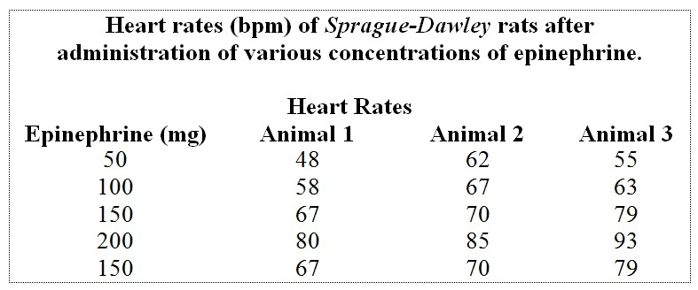
Table 1.1

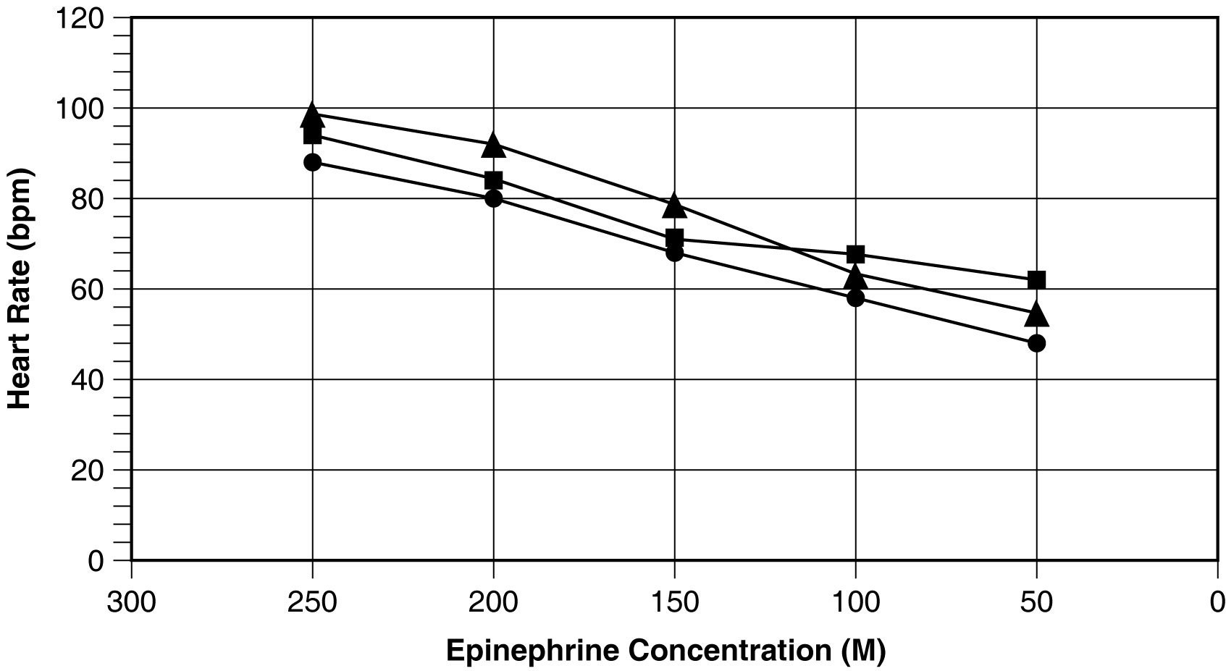
Figure 1.1

53) List all of the errors in Figure 1.1.
Answer:
1. The units of concentration are labeled as M when they should be mg.
2. The x-axis is in decreasing order of concentration.
3. The graph needs a legend.
Section: The Science of Physiology
Learning Outcome: 1.18
Bloom's Taxonomy: Analysis

54) What is the reason for using a line graph to express the results of this study?
Answer: Line graphs are commonly used when the independent variable (x-axis) is a continuous phenomenon. In this study the concentration of epinephrine is a continuous function. The line allows for interpolation (i.e., estimating values between the measured values).
Section: The Science of Physiology
Learning Outcome: 1.18
Bloom's Taxonomy: Analysis
55) Use Table 1.1 to graph the data appropriately. What can you CONCLUDE based on the new figure?
Answer: Graphs should address the errors in Figure 1.1.
This small sample suggests that an increase in epinephrine concentration increases the average heart rate of Sprague-Dawley rats.
Section: The Science of Physiology
Learning Outcome: 1.18
Bloom's Taxonomy: Application

Use the table and graph below to answer the following questions.

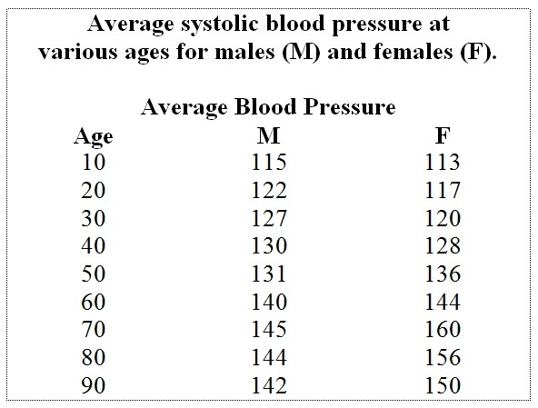
Table 1.2

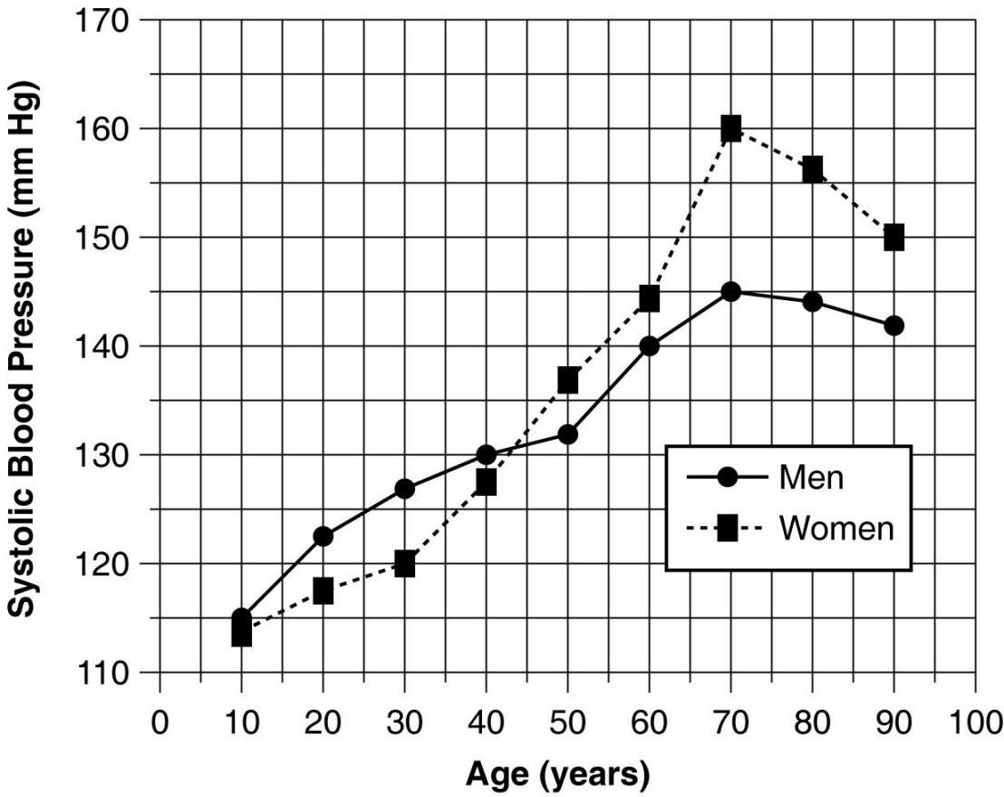
Figure 1.2

56) Summarize the data shown in Figure 1.2.
Answer: The systolic pressure of both genders increases with age. Under age 40, the systolic pressure of males is higher than that of females. After age 40, the systolic pressure of females is higher than that of males. The greatest rate of increase is from ages 50 to 70 in both genders. Blood pressure declines after age 70.
Section: The Science of Physiology
Learning Outcome: 1.18
Bloom's Taxonomy: Analysis
57) Referring to Table 1.2, what general trend in systolic blood pressures is seen as both men and women increase in age?
Answer: The systolic pressure of both genders increases with advancing age.
Section: The Science of Physiology
Learning Outcome: 1.18
Bloom's Taxonomy: Analysis

58) Referring to Figure 1.2, at approximately what age do men begin to show higher systolic blood pressures than women? At what age does this trend reverse?
Answer: From age 10 to 40, male pressures are higher; after age 40, female pressures are higher.
Section: The Science of Physiology
Learning Outcome: 1.18
Bloom's Taxonomy: Analysis

59) You are doing an experiment to determine if caffeine consumption affects reaction time.
A. Which is the dependent variable?
B. Which is the independent variable?
C. Briefly describe some ways you might manipulate the independent variable.
D. Name three stimuli you could use, and how you might measure reaction time for each.
E. Write an appropriate hypothesis for this study.
F. You compute the following average values from your experiment. What would be a logical conclusion for these data?
Average caffeine consumer's reaction time: 400 ms
Average noncaffeine consumer's reaction time: 650 ms
G. Sketch a simple graph to convey these results to your classmates. What kind of graph did you choose? Why? Which variable did you plot on the x-axis? Which one did you plot on the y-axis? Why?
H. Do the results of this experiment support the hypothesis you chose?
Answer:
A. Reaction time
B. Caffeine consumption
C. Vary the amounts of caffeine consumed; vary the source, for example, use coffee, pills, cola drinks, and/or chocolate; vary both the amounts and sources.
D. Answers will vary. Example: a computer-based timer could measure the time elapsed between the subject's detecting the appearance of an object on the computer monitor and depressing a key on the keyboard. Auditory or touch stimuli could be used, too.
E. Depending on the answer to C, could choose: "Consumption of caffeine decreases reaction time" or similar statement.
F. Consumption of caffeine improves reaction time by 250 ms, on average.
G. Bar graph; allows comparison of the average of two groups. The x-axis: group, caffeine or none. The y-axis: reaction time in milliseconds.
H. Yes, in case of hypothesis written in D.
Section: The Science of Physiology
Learning Outcome: 1.18
Bloom's Taxonomy: Analysis

Following is a table of data collected from one section of an 8 a.m. physiology lab. There were 20 students present, 10 men and 10 women. Information collected from the students included their height, weight, age, gender, and resting pulse rate. In addition, the students were surveyed to see if they smoked cigarettes, considered themselves "regular exercisers," if they had consumed caffeine the morning of the lab, and if they had eaten breakfast that day. A "y" or "n" (yes or no) was recorded to indicate their answers. Each student did "jumping jacks" for 5 minutes and recorded the time required to regain their resting heart rate, which is listed on the table as "recovery time." Finally, each student participated in an exercise designed to measure their reaction time (in milliseconds) in catching an object dropped by a lab partner according to specified criteria. Use this table to answer the following questions. Ignore statistical problems caused by small sample size, and so on.

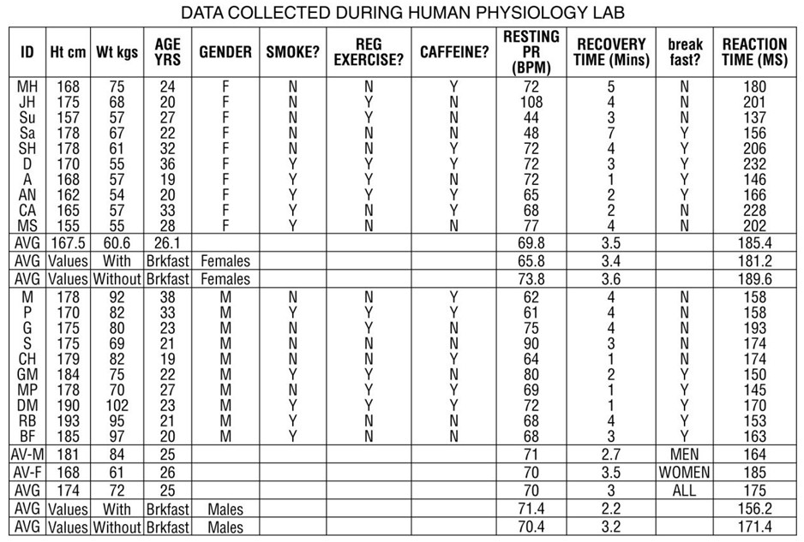
Table 1.3

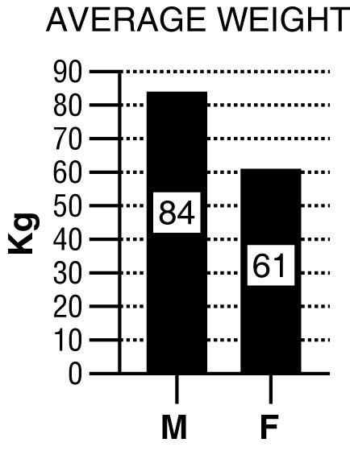
Figure 1.3

For these questions, the data were separated and analyzed by gender.

60) Refer to Table 1.3 and Figure 1.3 (bar graph).
A. Write a hypothesis regarding gender and weight.
B. What is the dependent variable? What is the independent variable?
C. Based on the data in the graph above, what is your conclusion?
D. Why is a bar graph a good choice for presentation of these data? Would another type of chart be as effective?
Answer:
A. Males weigh more than females.
B. Weight depends on gender; thus weight is dependent, gender is independent.
C. Males weigh more than females.
D. Bar graph allows comparison of the average of two groups. No.
Section: The Science of Physiology
Learning Outcome: 1.18
Bloom's Taxonomy: Analysis

61) Refer to Table 1.3.
A. Write a hypothesis regarding gender and recovery time.
B. What is the dependent variable? What is the independent variable?
C. Create a graph using the averages from the data table. Based on these data, what do you conclude?
Answer:
A. A prediction such as "Males recover from exercise more quickly than females" would be appropriate.
B. The independent variable is gender; the dependent variable is recovery time.
C. A bar graph such as the one below is appropriate. In this study, men recovered from exercise more quickly than women.

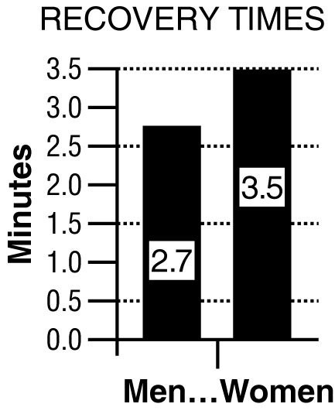
Section: The Science of Physiology
Learning Outcome: 1.18
Bloom's Taxonomy: Analysis

62) Refer to Table 1.3.
A. Write a hypothesis regarding the effects of breakfast consumption on reaction time.
B. What is the dependent variable? What is the independent variable?
Answer:
A. A prediction such as "Eating breakfast prior to testing improves reaction time of subjects (compared to subjects who did not eat breakfast)" is appropriate.
B. The independent variable is breakfast consumption; the dependent variable is reaction time.
Section: The Science of Physiology
Learning Outcome: 1.18
Bloom's Taxonomy: Analysis
63) Refer to Table 1.3.
A. Disregarding gender, write a hypothesis that expresses the relationship between weight and height.
B. What is the dependent variable? What is the independent variable?
C. From the data in Table 1.3, construct a graph that examines this relationship.
Answer:
A. A prediction such as "As height increases, weight increases" would be appropriate.
B. The dependent variable would be weight, the independent variable is height.
C.
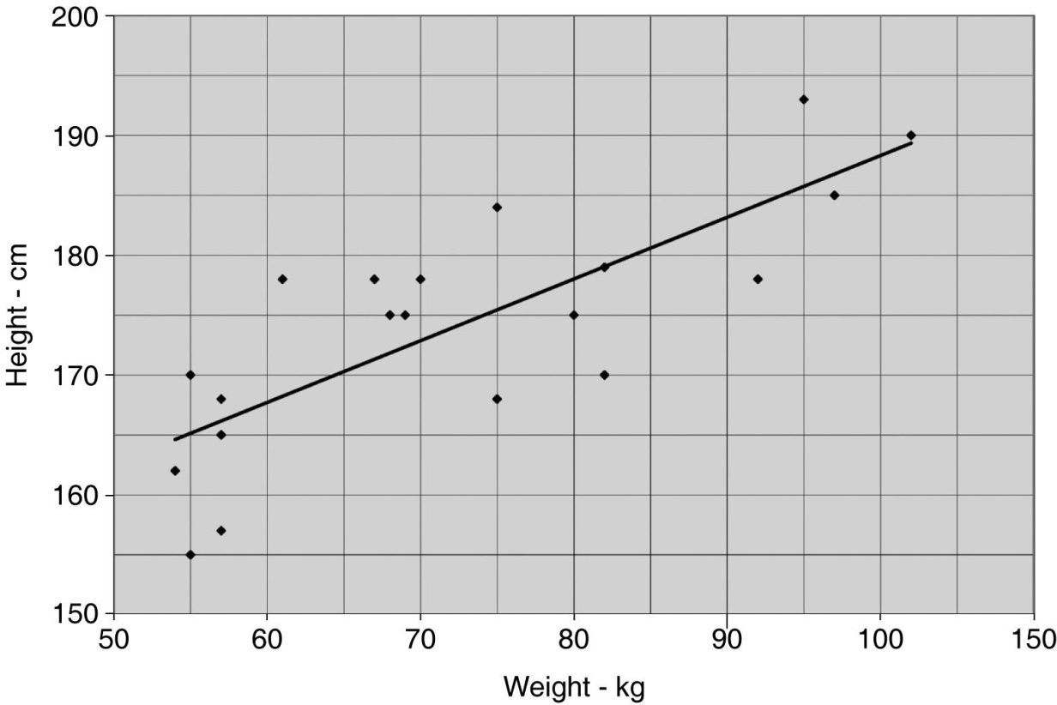
Section: The Science of Physiology
Learning Outcome: 1.18
Bloom's Taxonomy: Analysis

64) Table 1.3 shows data on various factors that may or may not be related to resting pulse rate, time to recovery to resting pulse rate after a few minutes of exercise, and reaction time measured by how quickly a student could press a keyboard key after seeing a computer-generated prompt. For each question below, write a testable hypothesis, identify the dependent and independent variables, sketch an appropriate graph of the results, and draw a conclusion from the data presented in the table. Discuss your results.
A. Does caffeine consumption have an effect on resting pulse rate?
B. Does age play a role in resting pulse rate? Does weight?
C. Is there a relationship between eating breakfast and recovery time?
D. Is there a relationship between reaction time and height?
E. Do women who smoke show differences in their resting pulse rates compared to female nonsmokers or to male smokers and nonsmokers?
F. Does regular exercise have an effect on resting pulse rate?
Answer: Answers will vary, but examples follow (conclusions written here are based on cursory examination of graphed data—no statistical tests of significance were performed).
A. Hypothesis: Caffeine consumption increases heart rate.
Independent variable: caffeine consumption.
Dependent variable: resting pulse rate.
Conclusion: Mean pulse rates between caffeine-drinking (68 bpm) and control subjects 73 bpm) are similar (large variation between individuals); hypothesis rejected.
B. Hypothesis: Pulse rate is lower in older people and is higher in heavier people.
Independent variables: age and weight.
Dependent variables: resting pulse rate.
Conclusion: Pulse rate was similar in all groups; hypothesis rejected.
C. Hypothesis: People who ate breakfast have a faster reaction time.
Independent variable: breakfast consumption.
Dependent variable: pulse rate.
Conclusion: People who ate breakfast had a faster reaction time (168.7 msec vs. 180.5 msec); hypothesis supported.
D. Hypothesis: There is no relationship between height and reaction time.
Independent variable: height.
Dependent variable: reaction time.
Conclusion: Reaction time did not vary with height; hypothesis supported.
E. Hypothesis: Smokers of both genders have a higher resting pulse rate than nonsmokers of either gender, and males and females are affected equally.
Independent variables: smoking and gender.
Dependent variable: pulse rate.
Conclusion: There was no difference in pulse rate in any of the groups (70.4 bpm in nonsmokers vs. 70.3 bpm in smokers); hypothesis rejected.
F. Hypothesis: People who exercise regularly have a lower resting pulse rate.
Independent variable: exercise.
Dependent variable: pulse rate.
Conclusion: Regular exercise had no effect on resting pulse rate (68.9 bpm in nonexercisers vs. 71.8 bpm in exercisers); hypothesis rejected.

Discussion may cover issues such as the effect of small sample size, use of adults of limited age range, lack of control over treatments (Were the subjects honest about age, eating breakfast, consuming caffeine, smoking, and exercising? Were the quantitative data of height and weight determined in the lab using the same equipment and same data collector?), the value of statistical analysis, and so on. It is likely that students will be surprised by some of the results and could make erroneous conclusions. For example, pulse rate may vary with age, but without including children and senior citizens in the sample population, this trend would be missed.
Section: The Science of Physiology
Learning Outcome: 1.18
Bloom's Taxonomy: Analysis

65) The law of mass balance states:
A) if a substance is to remain constant any gain must be offset by an equal loss.
B) that homeostasis can be maintained when the load of a substance is continuously lost.
C) if one is to survive they must have a certain amount of mass.
D) that all matter is neither created or destroyed.
E) that all substances in the body have equal mass.
Answer: A
Section: The Science of Physiology
Learning Outcome: 1.8
Bloom's Taxonomy: Knowledge
66) Mass balance involves determining the total amount of a substance in the body. We can determine the rate of production (i.e. Mass Flow) of this substance by which of the following formulas?
A) intake + production - excretion - metabolism.
B) (amount of substance / min) × (concentration of the substance)
C) volume of flow / (amount of substance / min)
D) (concentration of a substance) / volume flow
E) (concentration of a substance) × (volume/min)
Answer: E
Section: The Science of Physiology
Learning Outcome: 1.9
Bloom's Taxonomy: Knowledge

67) ________ are kept within normal range by physiological control mechanisms which are used if the variable strays too far from its ________.
A) Setpoints, regulated variable
B) Independent variables, steady state
C) Regulated variables, setpoint
D) Dependent variables, lowest value
E) Steady state values, integrating center
Answer: C
Section: The Science of Physiology
Learning Outcome: 1.13
Bloom's Taxonomy: Knowledge

68) The vasodilation of blood vessels surrounding muscles due to the production of carbon dioxide during exercise is an example of which of the following?
A) neural control
B) long-distance control
C) reflex control
D) local control
E) hormonal control
Answer: D
Section: The Science of Physiology
Learning Outcome: 1.14
Bloom's Taxonomy: Comprehension

69) Which of the following are used to keep our systems at or near their setpoints?
A) positive feedback loops
B) response loops
C) feedback loops
D) open control loops
E) feedforward control loop
Answer: C
Section: The Science of Physiology
Learning Outcome: 1.15
Bloom's Taxonomy: Knowledge

